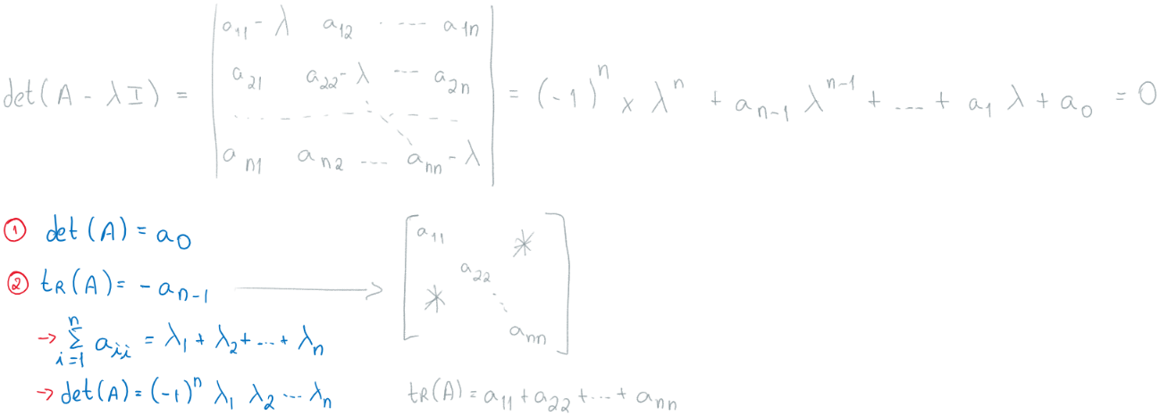

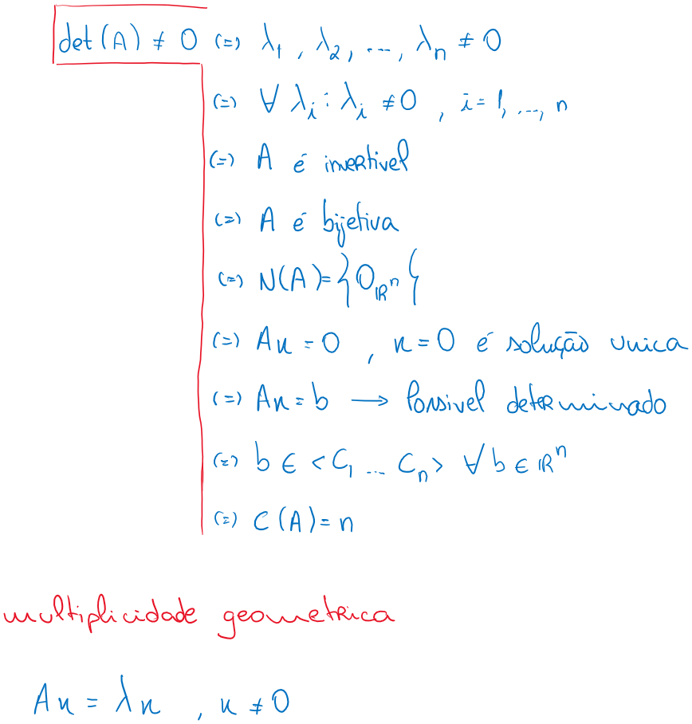

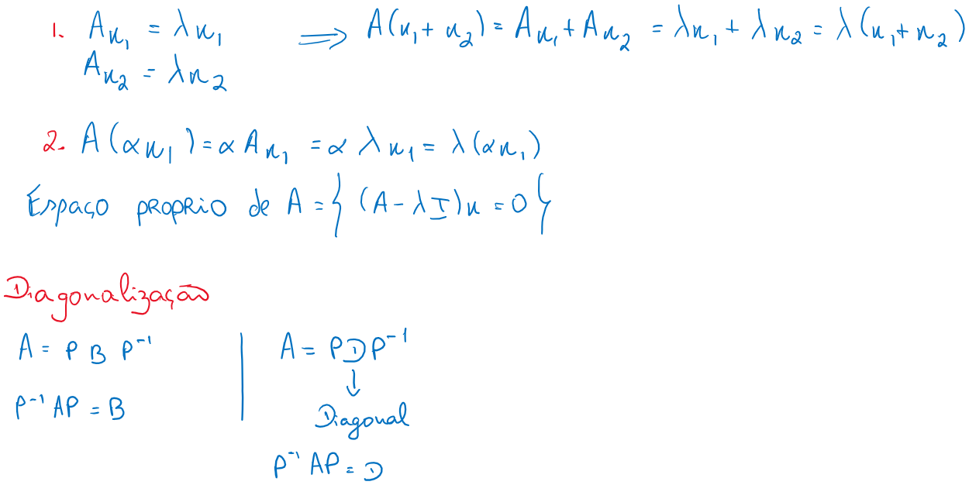

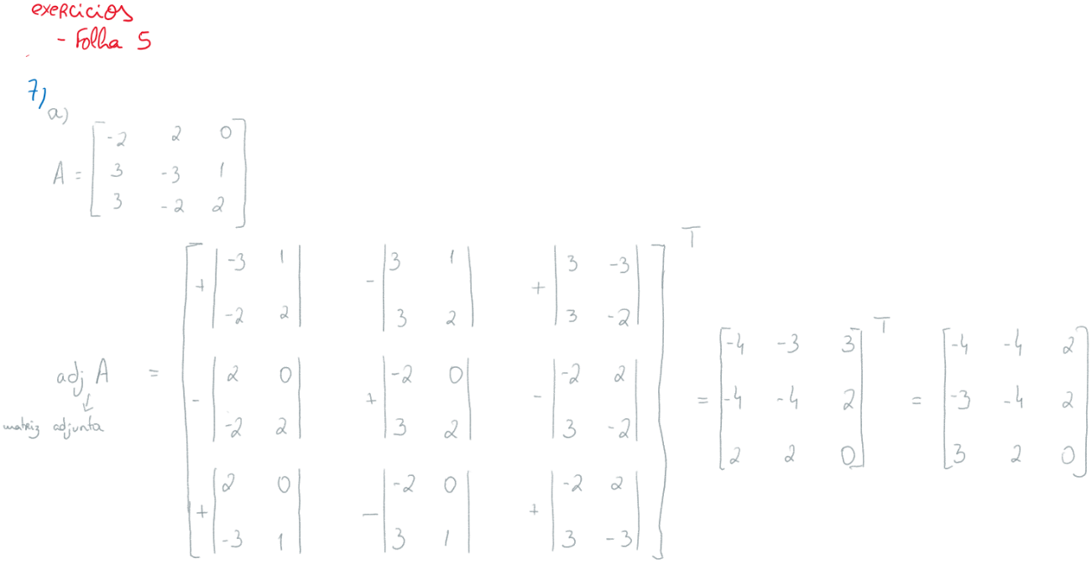

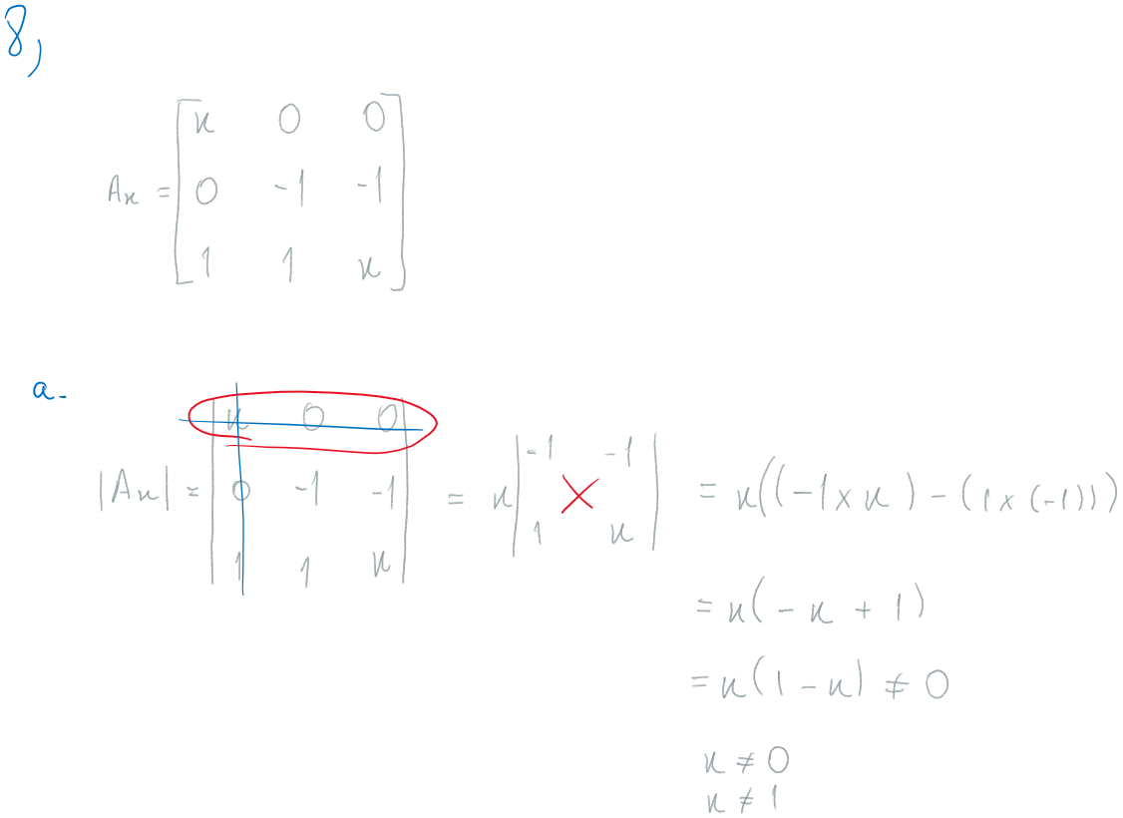

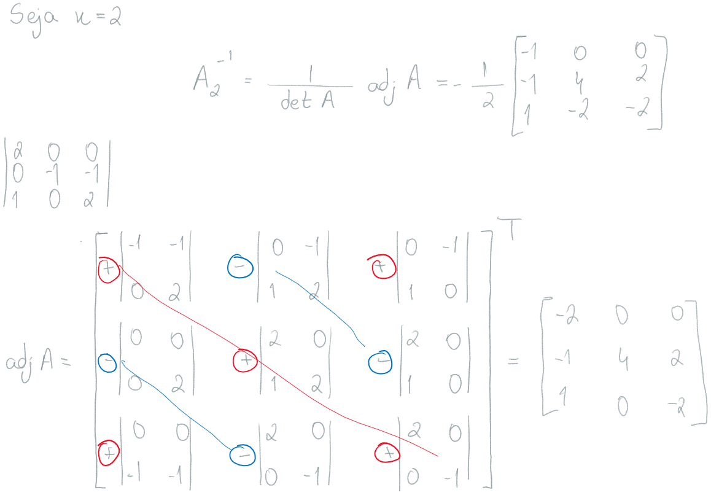

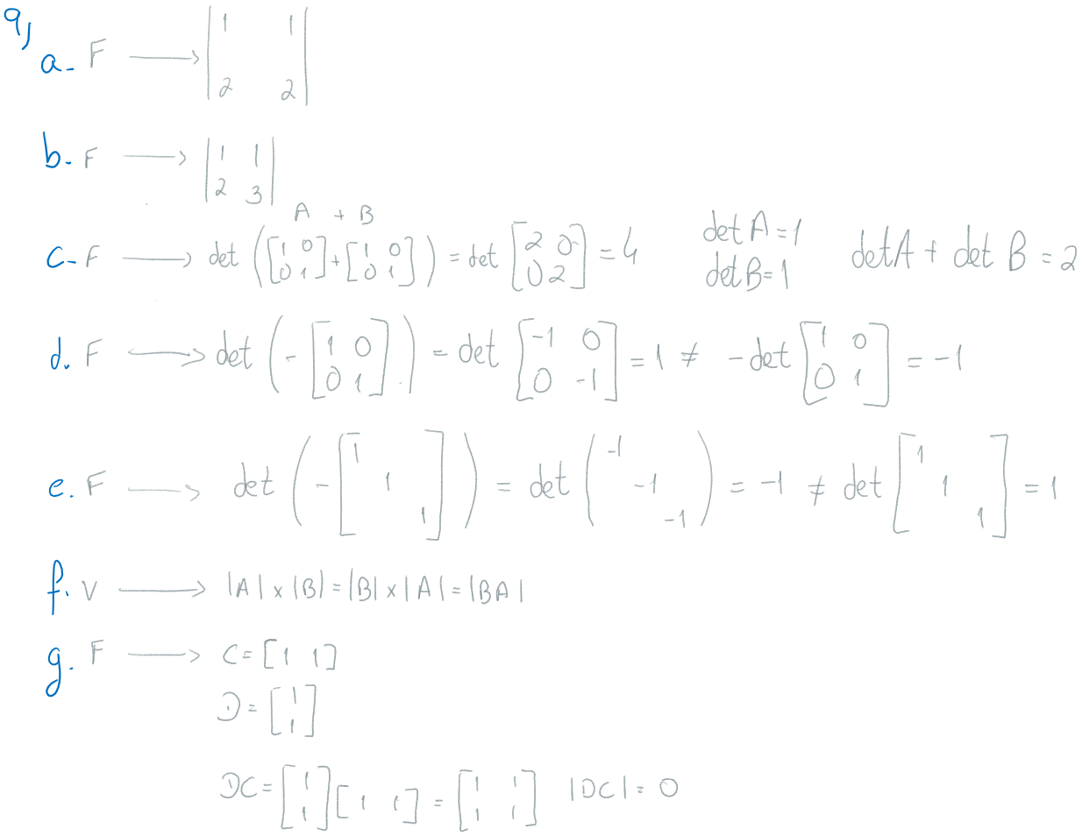

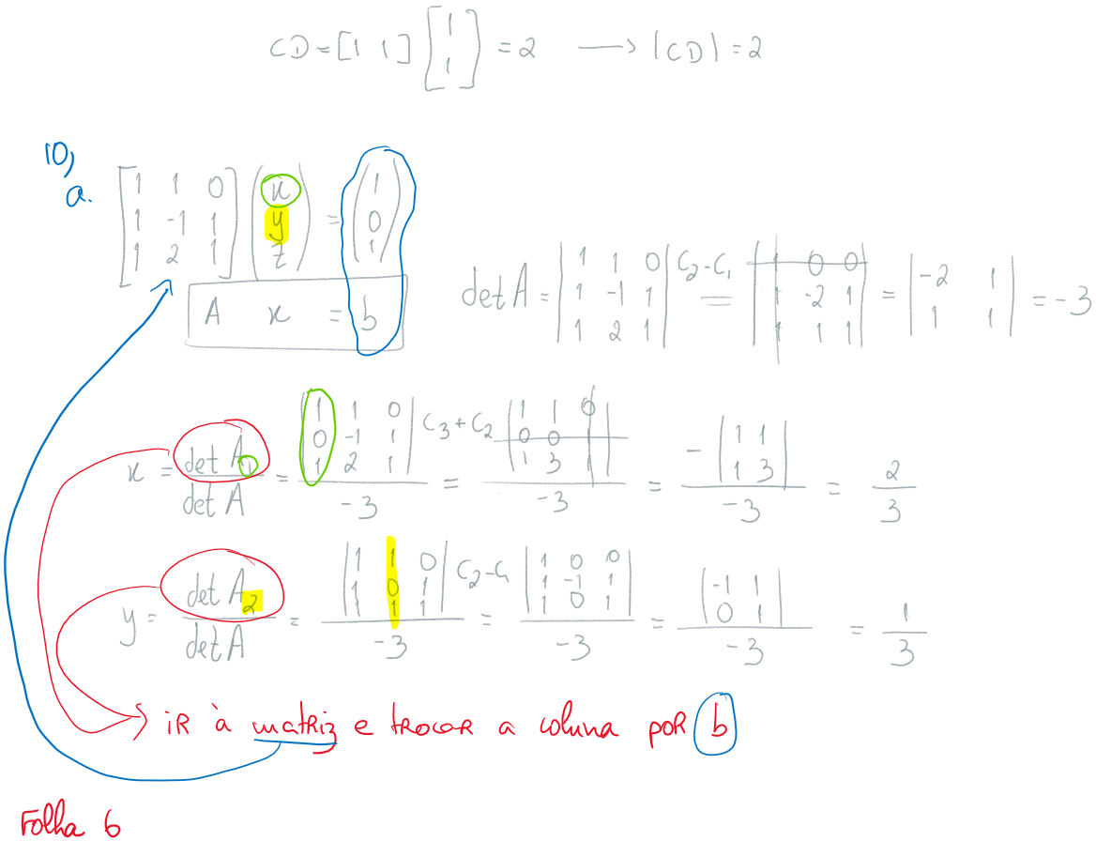

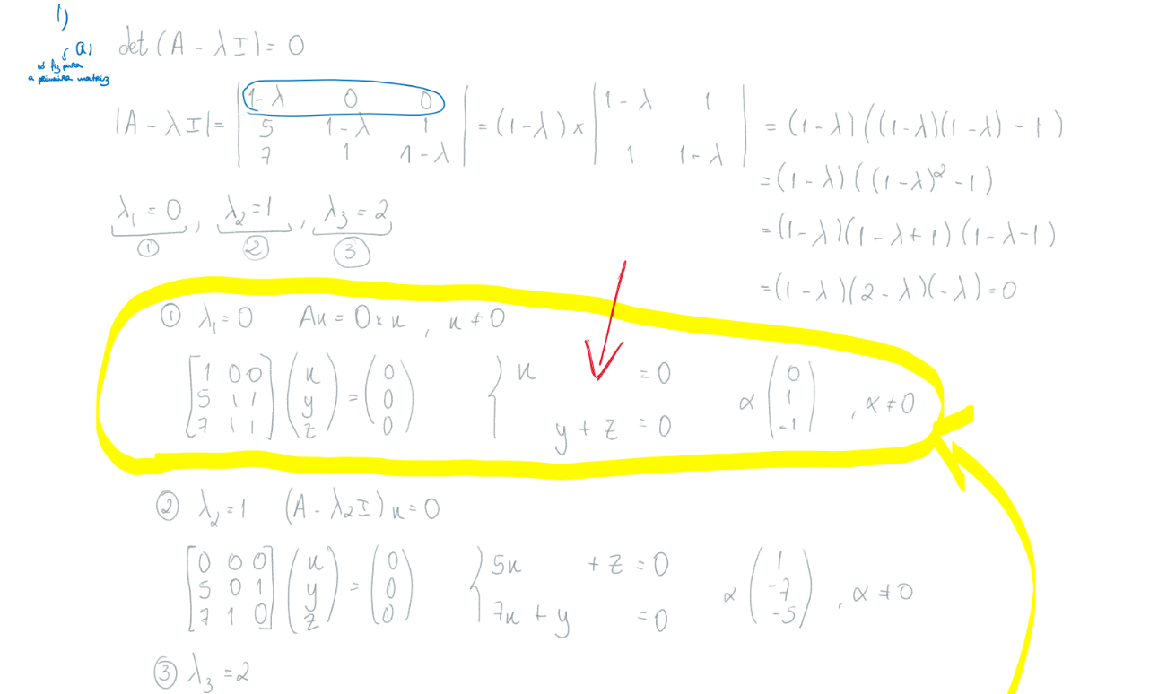  
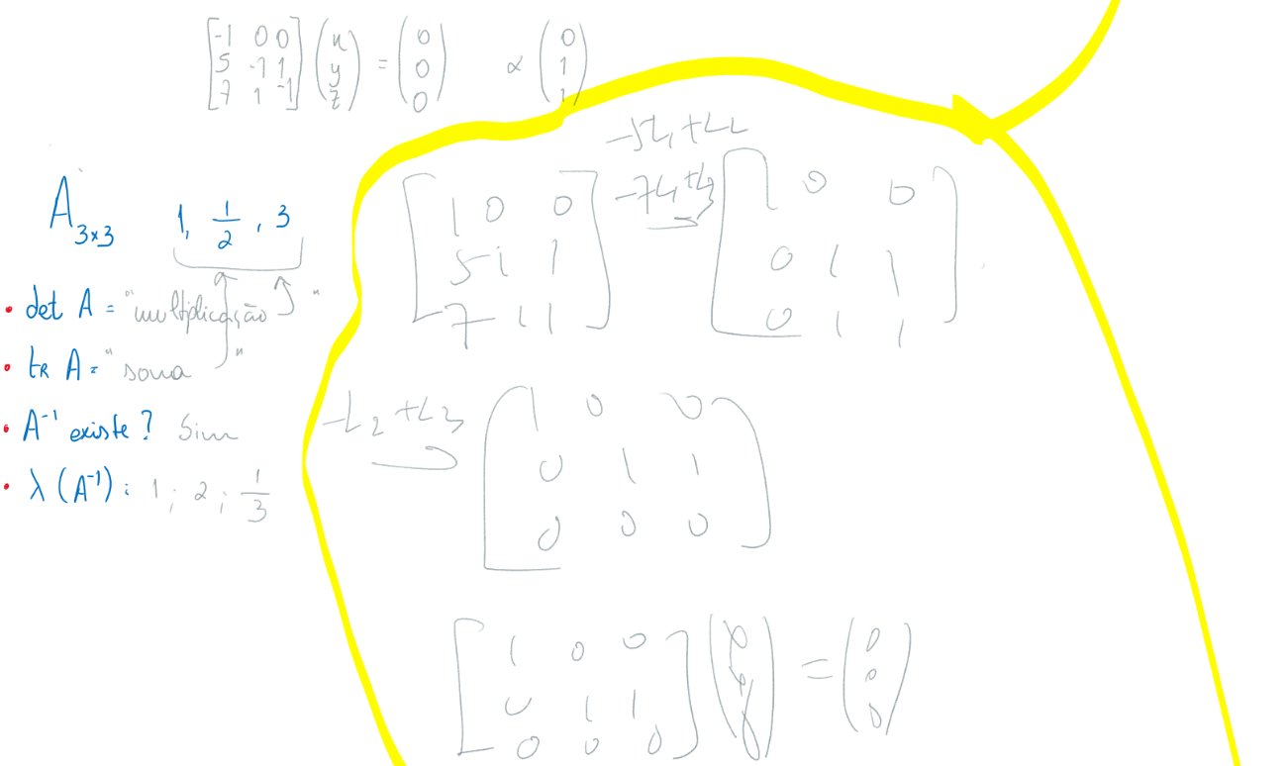  
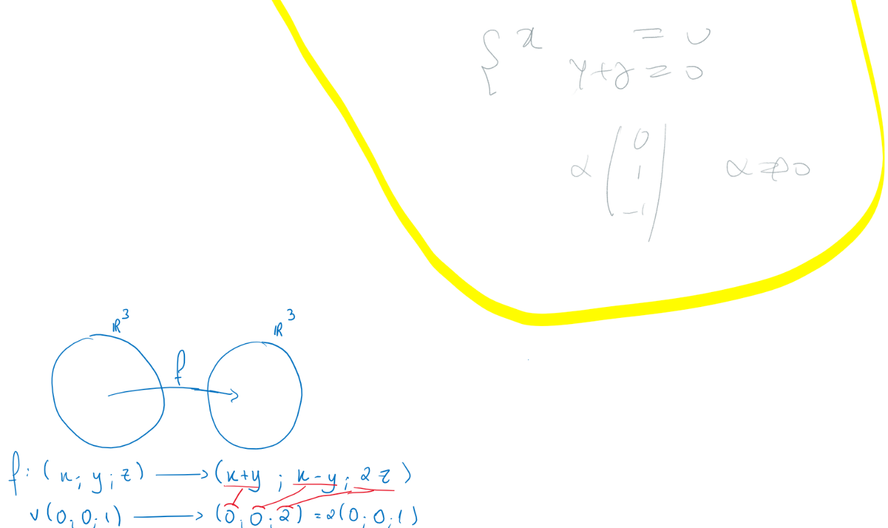  


|  |  |  |  |  |  |  |  |  |  |  |  |  |  |  |  |  |  |  |  |  |  |
| --- | --- | --- | --- | --- | --- | --- | --- | --- | --- | --- | --- | --- | --- | --- | --- | --- | --- | --- | --- | --- | --- |
|  |  |  |  |  |  |  |  |  |  |  |  |  |  |  |  |  |  |  |  |  |  |
|  |  |  |  |  |  |  |  |  |  |  |  |  |  |  |  |  |  |  | C:\Users\tiago\AppData\Local\Packages\Microsoft.Office.OneNote_8wekyb3d8bbwe\TempState\msohtmlclip\clip_image013.png |  |  |
|  |  |  |  |  |  |  |  |  |  |  |  |  |  |  |  |  |  |  |  | C:\Users\tiago\AppData\Local\Packages\Microsoft.Office.OneNote_8wekyb3d8bbwe\TempState\msohtmlclip\clip_image014.png |
|  |  |  |  |  | C:\Users\tiago\AppData\Local\Packages\Microsoft.Office.OneNote_8wekyb3d8bbwe\TempState\msohtmlclip\clip_image015.png |  |  |  |  |  |  |  |  |  |  |  |  |  |  |
|  |  |  | C:\Users\tiago\AppData\Local\Packages\Microsoft.Office.OneNote_8wekyb3d8bbwe\TempState\msohtmlclip\clip_image016.png |  |  |  |  |  |  |  |  |  |  |  |  |  |  |  |
|  |  |  |  |  |  |  |  |  |  |  |  |  | C:\Users\tiago\AppData\Local\Packages\Microsoft.Office.OneNote_8wekyb3d8bbwe\TempState\msohtmlclip\clip_image017.png |  |  |  |  |
|  |  |  |  |  |  |  |  |  |  |  | C:\Users\tiago\AppData\Local\Packages\Microsoft.Office.OneNote_8wekyb3d8bbwe\TempState\msohtmlclip\clip_image018.png |  |  |  |  |  |
|  |  |  |  |  |  |  | C:\Users\tiago\AppData\Local\Packages\Microsoft.Office.OneNote_8wekyb3d8bbwe\TempState\msohtmlclip\clip_image019.png |  |  |  |  |  |  |  |  |
|  | C:\Users\tiago\AppData\Local\Packages\Microsoft.Office.OneNote_8wekyb3d8bbwe\TempState\msohtmlclip\clip_image020.png |  |  |  |  |  |  |  |  |  |  |  |  |  |
|  |  |  |  |  |  |  |  |  |  |  | C:\Users\tiago\AppData\Local\Packages\Microsoft.Office.OneNote_8wekyb3d8bbwe\TempState\msohtmlclip\clip_image021.png |  |  |
|  |  |  |  | C:\Users\tiago\AppData\Local\Packages\Microsoft.Office.OneNote_8wekyb3d8bbwe\TempState\msohtmlclip\clip_image022.png |  |  |  |  |  |  |  |  |
|  |  |  |  |  |  | C:\Users\tiago\AppData\Local\Packages\Microsoft.Office.OneNote_8wekyb3d8bbwe\TempState\msohtmlclip\clip_image023.png |  |  |  |  |  |
|  |  |  |  |  |  |  |  |  |  |  |  |
|  |  |  |  |  |  |  |  |  |  |  |  |  |
|  |  |  |  |  |  |  |  |  |  |  |  |  |  |
|  |  |  |  |  |  |  |  |  |  |  |  |  |  |  |
|  |  |  |  |  |  |  |  |  |  |  |  |  |  |  |  |
|  |  |  |  |  |  |  |  |  |  |  |  |  |  |  |  |  |
|  |  |  |  |  |  |  |  |  |  |  |  |  |  |  |  |  |  |
|  |  |  |  |  |  |  |  |  |  |  |  |  |  |  |  |  |  |  |
|  |  |  |  |  |  |  |  |  |  |  |  |  |  |  |  |  |  |  |  |
|  |  |  |  |  |  |  |  |  |  |  |  |  |  |  |  |  |  |  |  |  |

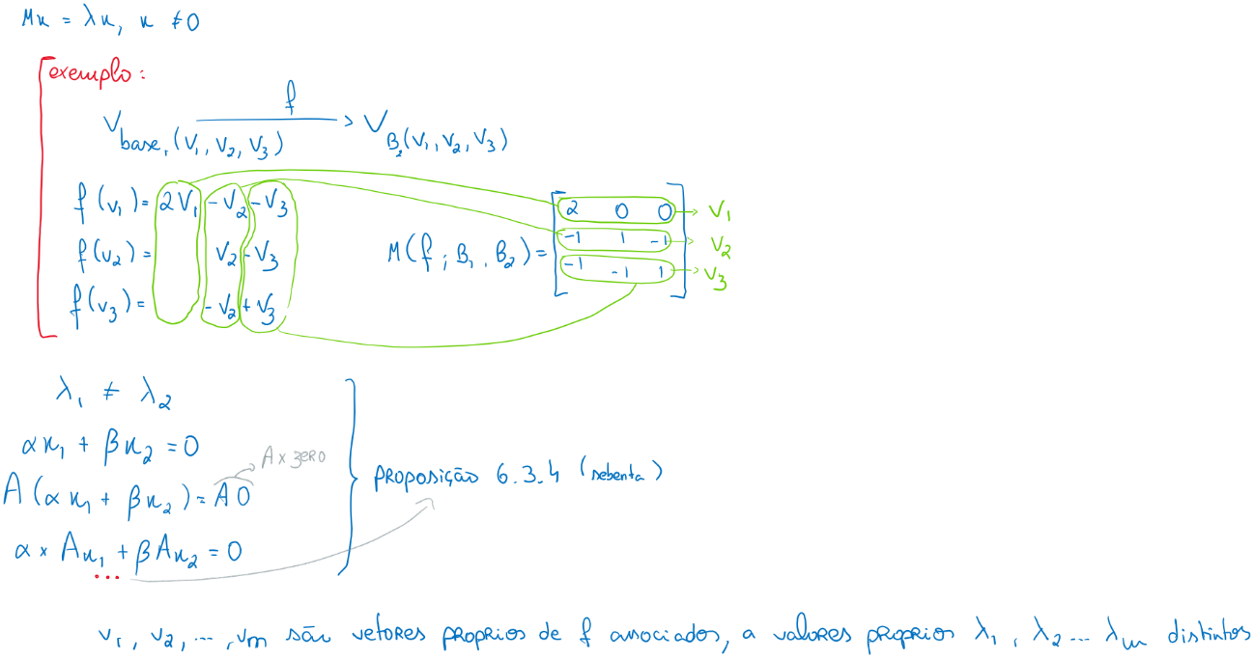

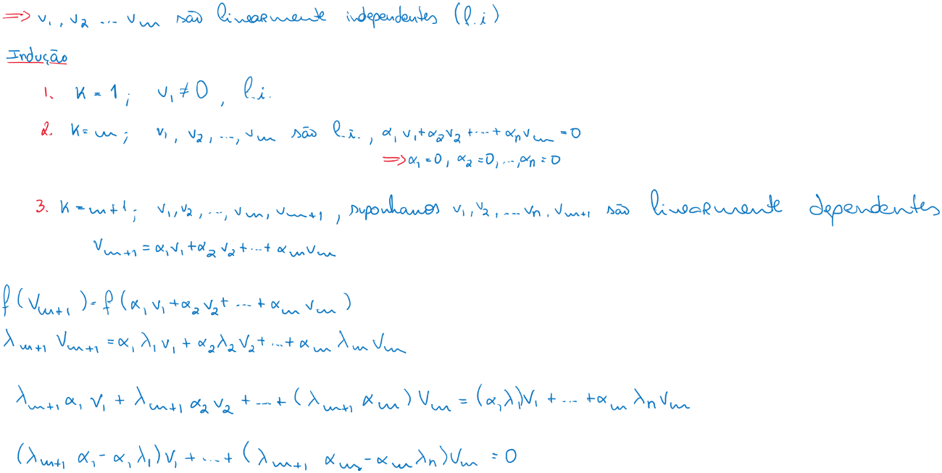

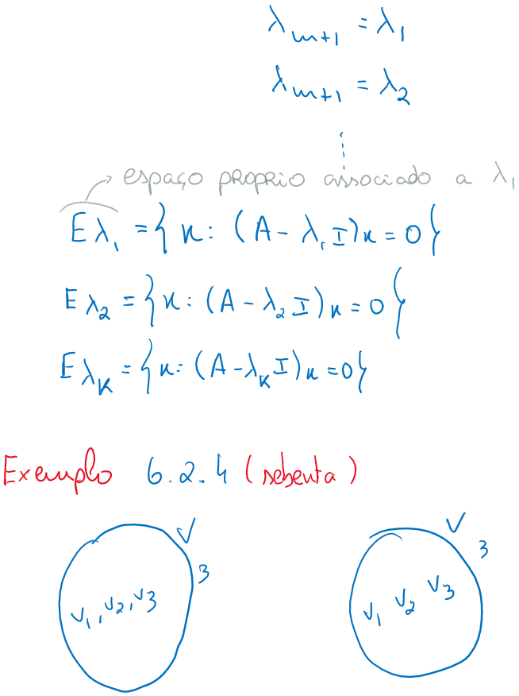

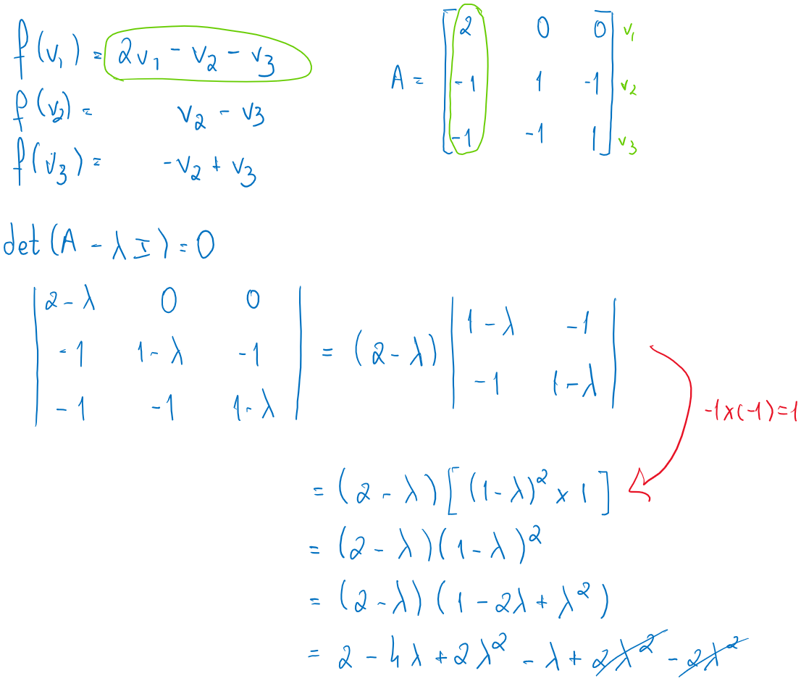

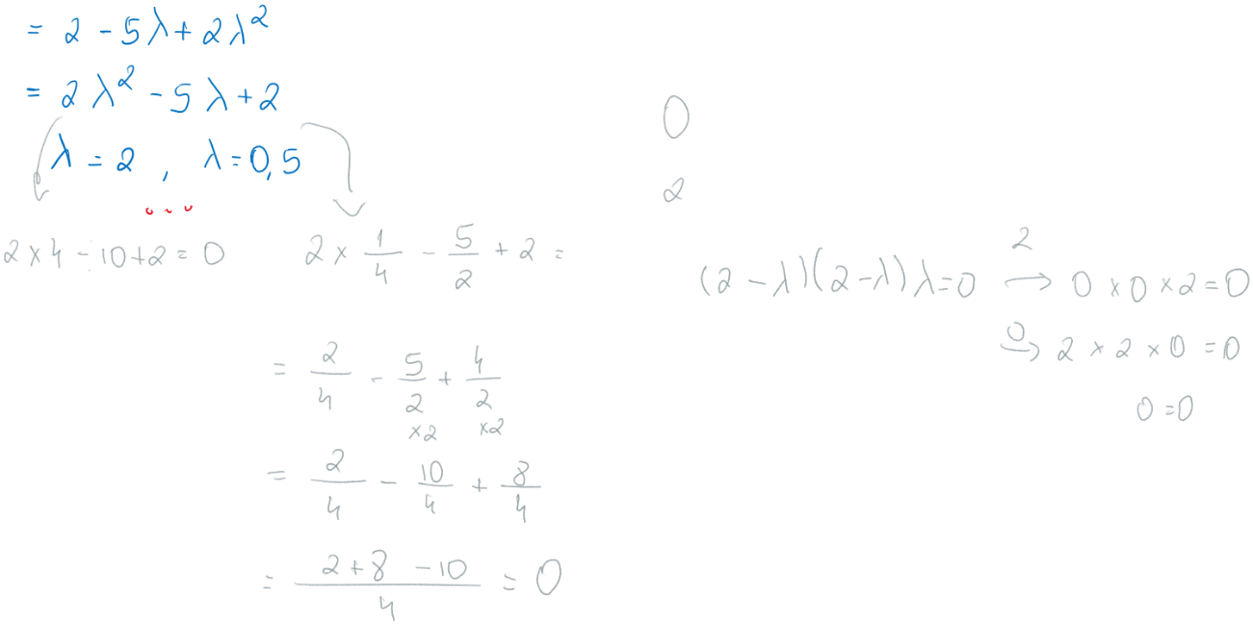

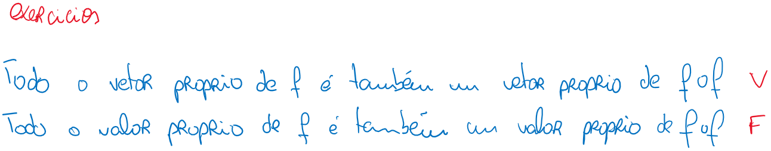

|  |  |  |  |  |  |  |  |  |  |  |  |  |  |  |  |  |  |  |  |  |  |  |  |  |  |  |  |  |  |  |  |  |  |  |  |  |  |  |  |  |  |  |  |
| --- | --- | --- | --- | --- | --- | --- | --- | --- | --- | --- | --- | --- | --- | --- | --- | --- | --- | --- | --- | --- | --- | --- | --- | --- | --- | --- | --- | --- | --- | --- | --- | --- | --- | --- | --- | --- | --- | --- | --- | --- | --- | --- | --- |
|  |  |  |  |  |  |  |  |  |  |  |  |  |  |  |  |  |  |  |  |  |  |  |  |  |  |  |  |  |  |  |  |  |  |  |  |  |  |  |  |  |  |  |  |
|  |  |  |  |  |  |  |  |  |  |  |  |  |  |  |  |  |  |  |  |  |  |  |  |  |  |  |  |  |  |  |  |  |  |  |  |  |  |  |  |  | C:\Users\tiago\AppData\Local\Packages\Microsoft.Office.OneNote_8wekyb3d8bbwe\TempState\msohtmlclip\clip_image030.png |  |  |
|  |  |  |  |  |  |  |  |  |  |  |  |  |  |  |  |  |  |  | C:\Users\tiago\AppData\Local\Packages\Microsoft.Office.OneNote_8wekyb3d8bbwe\TempState\msohtmlclip\clip_image031.png |  |  |  |  |  |  |  |  |  |  |  |  |  |  |  |  |  |  |  |  |  |  |  |
|  |  |  |  |  |  |  |  |  |  |  |  |  |  |  |  |  |  |  |  |  |  |  |  |  |  |  |  |  |  |  |  |  |  | C:\Users\tiago\AppData\Local\Packages\Microsoft.Office.OneNote_8wekyb3d8bbwe\TempState\msohtmlclip\clip_image032.png |  |  |  |  |  |  |  |
|  |  |  |  |  |  |  |  |  |  |  |  |  |  |  |  |  |  |  |  |  |  |  |  | C:\Users\tiago\AppData\Local\Packages\Microsoft.Office.OneNote_8wekyb3d8bbwe\TempState\msohtmlclip\clip_image033.png |  |  |  |  |  |  |  |  |  |  |  |  |  |  |  |  |
|  |  |  |  |  |  |  |  |  |  |  |  |  | C:\Users\tiago\AppData\Local\Packages\Microsoft.Office.OneNote_8wekyb3d8bbwe\TempState\msohtmlclip\clip_image034.png |  |  |  |  |  |  |  |  |  |  |  |  |  |  |  |  |  |  |  |  |  |  |  |  |  |  |
|  |  |  |  |  |  |  |  |  |  |  |  |  |  |  |  |  |  |  |  |  |  |  |  |  |  | C:\Users\tiago\AppData\Local\Packages\Microsoft.Office.OneNote_8wekyb3d8bbwe\TempState\msohtmlclip\clip_image035.png |  |  |  |  |  |  |  |  |  |  |  |  |
|  |  |  |  |  |  |  |  |  |  |  |  |  |  |  |  |  |  |  |  |  |  |  |  |  |  |  |  |  |  |  |  |  |  | C:\Users\tiago\AppData\Local\Packages\Microsoft.Office.OneNote_8wekyb3d8bbwe\TempState\msohtmlclip\clip_image036.png |  |  |  |
|  |  |  |  |  |  |  |  |  |  |  |  |  |  |  |  | C:\Users\tiago\AppData\Local\Packages\Microsoft.Office.OneNote_8wekyb3d8bbwe\TempState\msohtmlclip\clip_image037.png |  |  |  |  |  |  |  |  |  |  |  |  |  |  |  |  |  |  |  |  |
|  |  |  |  |  |  |  |  |  |  |  |  |  |  |  |  |  |  | C:\Users\tiago\AppData\Local\Packages\Microsoft.Office.OneNote_8wekyb3d8bbwe\TempState\msohtmlclip\clip_image038.png |  |  |  |  |  |  |  |  |  |  |  |  |  |  |  |  |  |
|  |  |  |  |  |  |  |  |  |  |  |  |  |  |  |  |  |  |  |  |  |  |  |  |  |  |  |  |  |  |  |  |  |  | C:\Users\tiago\AppData\Local\Packages\Microsoft.Office.OneNote_8wekyb3d8bbwe\TempState\msohtmlclip\clip_image039.png |
|  | C:\Users\tiago\AppData\Local\Packages\Microsoft.Office.OneNote_8wekyb3d8bbwe\TempState\msohtmlclip\clip_image040.png |  |  |  |  |  |  |  |  |  |  |  |  |  |  |  |  |  |  |  |  |  |  |  |  |  |  |  |  |  |  |  |  |
|  |  |  |  |  |  |  |  |  |  |  |  |  |  |  |  |  |  |  |  |  |  |  |  |  |  | C:\Users\tiago\AppData\Local\Packages\Microsoft.Office.OneNote_8wekyb3d8bbwe\TempState\msohtmlclip\clip_image041.png |  |  |  |  |  |  |
|  |  |  |  |  |  |  |  | C:\Users\tiago\AppData\Local\Packages\Microsoft.Office.OneNote_8wekyb3d8bbwe\TempState\msohtmlclip\clip_image042.png |  |  |  |  |  |  |  |  |  |  |  |  |  |  |  |  |  |  |  |  |  |  |  |
|  |  |  |  |  |  |  |  |  |  |  |  |  |  |  |  |  |  |  |  | C:\Users\tiago\AppData\Local\Packages\Microsoft.Office.OneNote_8wekyb3d8bbwe\TempState\msohtmlclip\clip_image043.png |  |  |  |  |  |  |  |  |  |  |
|  |  |  |  |  |  |  |  |  | C:\Users\tiago\AppData\Local\Packages\Microsoft.Office.OneNote_8wekyb3d8bbwe\TempState\msohtmlclip\clip_image044.png |  |  |  |  |  |  |  |  |  |  |  |  |  |  |  |  |  |  |  |  |
|  |  |  |  |  |  | C:\Users\tiago\AppData\Local\Packages\Microsoft.Office.OneNote_8wekyb3d8bbwe\TempState\msohtmlclip\clip_image045.png |  |  |  |  |  |  |  |  |  |  |  |  |  |  |  |  |  |  |  |  |  |  |
|  |  |  |  |  |  |  |  |  |  |  |  |  |  |  |  |  |  |  |  | C:\Users\tiago\AppData\Local\Packages\Microsoft.Office.OneNote_8wekyb3d8bbwe\TempState\msohtmlclip\clip_image046.png |  |  |  |  |  |  |  |
|  |  |  |  |  |  |  |  |  |  | C:\Users\tiago\AppData\Local\Packages\Microsoft.Office.OneNote_8wekyb3d8bbwe\TempState\msohtmlclip\clip_image047.png |  |  |  |  |  |  |  |  |  |  |  |  |  |  |  |  |
|  |  |  |  |  |  |  |  |  |  |  |  |  |  |  |  |  |  |  |  |  |  | C:\Users\tiago\AppData\Local\Packages\Microsoft.Office.OneNote_8wekyb3d8bbwe\TempState\msohtmlclip\clip_image048.png |  |  |  |
|  |  | C:\Users\tiago\AppData\Local\Packages\Microsoft.Office.OneNote_8wekyb3d8bbwe\TempState\msohtmlclip\clip_image049.png |  |  |  |  |  |  |  |  |  |  |  |  |  |  |  |  |  |  |  |  |  |  |
|  |  |  |  |  |  |  |  |  |  |  |  |  | C:\Users\tiago\AppData\Local\Packages\Microsoft.Office.OneNote_8wekyb3d8bbwe\TempState\msohtmlclip\clip_image050.png |  |  |  |  |  |  |  |  |  |  |
|  |  |  | C:\Users\tiago\AppData\Local\Packages\Microsoft.Office.OneNote_8wekyb3d8bbwe\TempState\msohtmlclip\clip_image051.png |  |  |  |  |  |  |  |  |  |  |  |  |  |  |  |  |  |  |  |
|  |  |  |  |  |  |  |  |  |  |  |  |  |  |  |  |  |  |  |  |  |  |  |
|  |  |  |  |  |  |  |  |  |  |  |  |  |  |  |  |  |  |  |  |  |  |  |  |
|  |  |  |  |  |  |  |  |  |  |  |  |  |  |  |  |  |  |  |  |  |  |  |  |  |
|  |  |  |  |  |  |  |  |  |  |  |  |  |  |  |  |  |  |  |  |  |  |  |  |  |  |
|  |  |  |  |  |  |  |  |  |  |  |  |  |  |  |  |  |  |  |  |  |  |  |  |  |  |  |
|  |  |  |  |  |  |  |  |  |  |  |  |  |  |  |  |  |  |  |  |  |  |  |  |  |  |  |  |
|  |  |  |  |  |  |  |  |  |  |  |  |  |  |  |  |  |  |  |  |  |  |  |  |  |  |  |  |  |
|  |  |  |  |  |  |  |  |  |  |  |  |  |  |  |  |  |  |  |  |  |  |  |  |  |  |  |  |  |  |
|  |  |  |  |  |  |  |  |  |  |  |  |  |  |  |  |  |  |  |  |  |  |  |  |  |  |  |  |  |  |  |  |
|  |  |  |  |  |  |  |  |  |  |  |  |  |  |  |  |  |  |  |  |  |  |  |  |  |  |  |  |  |  |  |  |  |
|  |  |  |  |  |  |  |  |  |  |  |  |  |  |  |  |  |  |  |  |  |  |  |  |  |  |  |  |  |  |  |  |  |  |
|  |  |  |  |  |  |  |  |  |  |  |  |  |  |  |  |  |  |  |  |  |  |  |  |  |  |  |  |  |  |  |  |  |  |  |
|  |  |  |  |  |  |  |  |  |  |  |  |  |  |  |  |  |  |  |  |  |  |  |  |  |  |  |  |  |  |  |  |  |  |  |  |
|  |  |  |  |  |  |  |  |  |  |  |  |  |  |  |  |  |  |  |  |  |  |  |  |  |  |  |  |  |  |  |  |  |  |  |  |  |
|  |  |  |  |  |  |  |  |  |  |  |  |  |  |  |  |  |  |  |  |  |  |  |  |  |  |  |  |  |  |  |  |  |  |  |  |  |  |
|  |  |  |  |  |  |  |  |  |  |  |  |  |  |  |  |  |  |  |  |  |  |  |  |  |  |  |  |  |  |  |  |  |  |  |  |  |  |  |
|  |  |  |  |  |  |  |  |  |  |  |  |  |  |  |  |  |  |  |  |  |  |  |  |  |  |  |  |  |  |  |  |  |  |  |  |  |  |  |  |
|  |  |  |  |  |  |  |  |  |  |  |  |  |  |  |  |  |  |  |  |  |  |  |  |  |  |  |  |  |  |  |  |  |  |  |  |  |  |  |  |  |
|  |  |  |  |  |  |  |  |  |  |  |  |  |  |  |  |  |  |  |  |  |  |  |  |  |  |  |  |  |  |  |  |  |  |  |  |  |  |  |  |  |  |
|  |  |  |  |  |  |  |  |  |  |  |  |  |  |  |  |  |  |  |  |  |  |  |  |  |  |  |  |  |  |  |  |  |  |  |  |  |  |  |  |  |  |  |

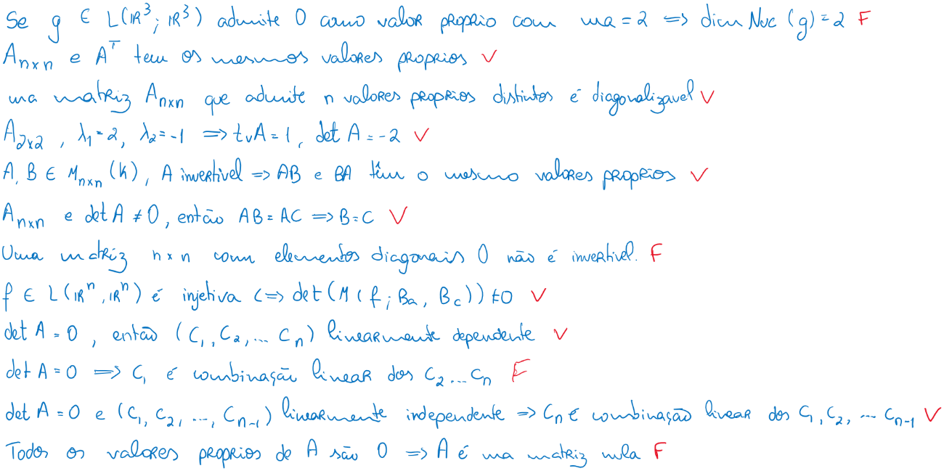

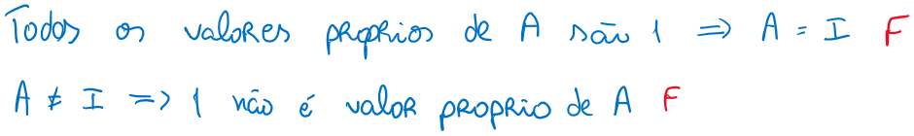

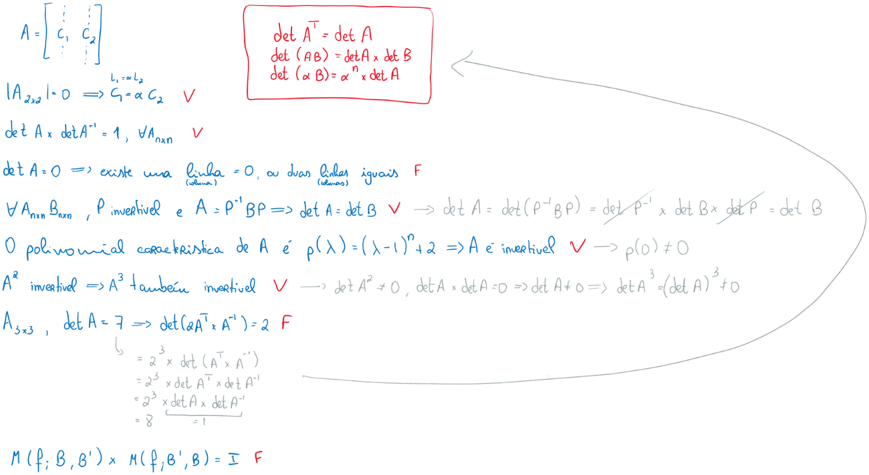

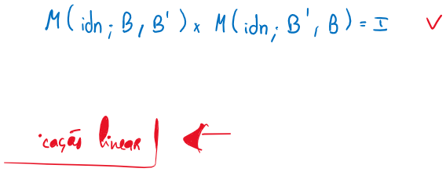

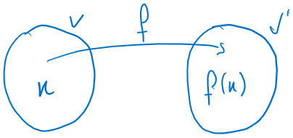

|  |  |  |  |  |  |  |  |  |  |  |  |  |  |  |  |  |  |  |  |  |  |
| --- | --- | --- | --- | --- | --- | --- | --- | --- | --- | --- | --- | --- | --- | --- | --- | --- | --- | --- | --- | --- | --- |
|  |  |  |  |  |  |  |  |  |  |  |  |  |  |  |  |  |  |  |  |  |  |
|  |  |  |  |  | C:\Users\tiago\AppData\Local\Packages\Microsoft.Office.OneNote_8wekyb3d8bbwe\TempState\msohtmlclip\clip_image057.png |  |  |  |  |  |  |  |  |  |  |  |  |  |  |  |  |
|  |  | C:\Users\tiago\AppData\Local\Packages\Microsoft.Office.OneNote_8wekyb3d8bbwe\TempState\msohtmlclip\clip_image058.png |  |  |  |  |  |  |  |  |  |  |  |  |  |  |  |  |  |  |
|  |  |  |  |  |  |  |  |  |  |  |  |  |  |  |  |  | C:\Users\tiago\AppData\Local\Packages\Microsoft.Office.OneNote_8wekyb3d8bbwe\TempState\msohtmlclip\clip_image059.png |  |  |
|  |  |  |  |  |  |  |  |  |  |  |  |  | C:\Users\tiago\AppData\Local\Packages\Microsoft.Office.OneNote_8wekyb3d8bbwe\TempState\msohtmlclip\clip_image060.png |  |  |  |  |  |
|  |  |  |  |  |  |  |  |  | C:\Users\tiago\AppData\Local\Packages\Microsoft.Office.OneNote_8wekyb3d8bbwe\TempState\msohtmlclip\clip_image061.png |  |  |  |  |  |  |  |  |
|  |  |  |  |  |  |  | C:\Users\tiago\AppData\Local\Packages\Microsoft.Office.OneNote_8wekyb3d8bbwe\TempState\msohtmlclip\clip_image062.png |  |  |  |  |  |  |  |  |  |
|  |  |  |  |  |  |  |  |  |  |  |  |  |  |  | C:\Users\tiago\AppData\Local\Packages\Microsoft.Office.OneNote_8wekyb3d8bbwe\TempState\msohtmlclip\clip_image063.png |
|  |  |  |  |  | C:\Users\tiago\AppData\Local\Packages\Microsoft.Office.OneNote_8wekyb3d8bbwe\TempState\msohtmlclip\clip_image064.png |  |  |  |  |  |  |  |  |  |
|  |  |  |  |  |  |  |  |  |  |  |  |  |  |  |
|  |  |  |  |  |  |  |  |  | C:\Users\tiago\AppData\Local\Packages\Microsoft.Office.OneNote_8wekyb3d8bbwe\TempState\msohtmlclip\clip_image065.png |  |  |  |  |  |
|  |  |  |  |  |  |  |  |  |  |  | C:\Users\tiago\AppData\Local\Packages\Microsoft.Office.OneNote_8wekyb3d8bbwe\TempState\msohtmlclip\clip_image066.png |  |  |
|  |  |  |  |  |  |  |  |  |  |  |  |  |  |
|  |  |  |  |  |  |  |  |  |  |  |  |  |  |  |
|  |  |  |  |  |  |  |  |  |  |  |  |  |  |  |  |
|  |  |  |  |  |  |  |  |  |  |  |  |  |  |  |  |  |
|  |  |  |  |  |  |  |  |  |  |  |  |  |  |  |  |  |  |
|  | C:\Users\tiago\AppData\Local\Packages\Microsoft.Office.OneNote_8wekyb3d8bbwe\TempState\msohtmlclip\clip_image067.png | | |  |  |  |  |  |  |  |  |  |  |  |  |  |  |
|  |  |  |  |  |  |  |  |  |  |  |  |  |  |  |  |
|  |  |  |  |  |  |  |  |  |  |  |  |  |  |  |  |  |
|  |  |  |  |  |  |  |  |  |  |  |  |  |  |  |  |  |  |
|  |  |  |  |  |  |  |  |  |  |  |  |  |  |  |  |  |  |  |  |  |

